GOVERNMENT OF INDIA
Ministry of Commerce & Industry | NICDC
Industrial Corridor Project Management System (IC-PMS)

MODULE 6
Document Management
System (DMS)
NIC DigiLocker / Bharat Cloud Aligned | OCR Full-Text | eSign / DSC | 30-Year GFR Retention
Detailed Design Document

Document Version: 1.0 | March 2026 | Classification: Restricted
Prepared by: IC-PMS Solution Architect Team | NICDC / Ministry of Commerce & Industry

1. Module Overview

1.1 Purpose & Objectives
Module 6 — Document Management System (DMS) — is the institutional memory of IC-PMS. It stores, organises, versions, transmits, approves, and archives every document produced across the full lifecycle of India's industrial corridor programme — from the first DPR feasibility study to the final as-built drawing handed over to the operating company thirty years later. The module serves as the single authoritative repository for all project documentation: engineering drawings, contracts, approvals, correspondence, quality records, safety reports, financial documents, meeting minutes, and regulatory clearances.
Module 6 is deeply integrated with every other IC-PMS module. Module 1 generates WBS-linked folder structures automatically on WBS publish. Module 2 stores schedule baselines and look-ahead reports. Module 3 archives satellite evidence packages. Module 4 files RA bills, payment records, and audit reports. Module 5 stores tender documents, bid evaluations, and contract correspondence. All modules deposit their outputs into Module 6 as the centralised document store, making it the single source of truth for project records, audit, and compliance.
The DMS is designed in alignment with NIC's digital governance framework — using NIC DigiLocker and Bharat Cloud for sovereign document storage, Aadhaar eSign and DSC for digital signatures, and Elasticsearch for full-text OCR search across all document types. A 30-year retention policy is built into the system architecture in compliance with GFR 2017 records management requirements and the National Archives of India guidelines.

1.2 Module Scope
Capability | Included | Technology / Standard
WBS-mirrored folder hierarchy (auto-created on WBS publish) | Yes | Module 1 integration; 8-level hierarchy
Multi-format document ingestion (PDF, DWG, DOCX, XLSX, PNG, DXF) | Yes | GDAL, LibreOffice conversion, Apache Tika
OCR full-text extraction and search indexing | Yes | Tesseract OCR; Apache Tika; Elasticsearch
Version control (major/minor versioning with diff) | Yes | Git-inspired append-only version history
Digital signature — Aadhaar eSign & USB DSC | Yes | CDAC eSign API; NSDL DSC; PDF/A-3
Transmittal management (issue, receipt, response tracking) | Yes | Primavera Unifier Document Manager aligned
Drawing register (discipline-wise, revision tracking, IFA/IFC/As-Built) | Yes | BS 1192 / ISO 19650 naming convention
RFI (Request for Information) register with SLA tracking | Yes | PMC-managed; response deadline enforcement
Submittal register (material approvals, shop drawings, method statements) | Yes | Contractor-PMC workflow; review status matrix
Full-text search with filters and relevance ranking | Yes | Elasticsearch; OCR-indexed PDFs; metadata filters
Role-based access control (RBAC) at folder and document level | Yes | Attribute-based; WBS-OBS access matrix
NIC DigiLocker / Bharat Cloud sovereign storage integration | Yes | DigiLocker API; REST; AES-256 encryption
Automated archival and 30-year retention lifecycle | Yes | GFR 2017; National Archives guidelines
Audit trail — every access, download, modification logged | Yes | Immutable Elasticsearch audit index
Bulk download and offline sync for field engineers | Yes | PWA / React Native mobile app

1.3 Key Design Principles
- WBS-first folder structure: Every folder in the DMS mirrors the WBS hierarchy — documents are always findable by navigating the project structure, not by knowing arbitrary folder names
- Document-of-record: Once a document version is approved and locked, it cannot be modified or deleted — only superseded by a new version; this creates a tamper-proof record aligned with GFR and CAG requirements
- OCR everything: All uploaded documents are automatically OCR-processed and indexed for full-text search — even scanned PDFs from the field become searchable within minutes of upload
- Sovereign cloud storage: All documents stored exclusively on NIC DigiLocker and Bharat Cloud data centres within India — no third-party international cloud storage; data sovereignty maintained
- eSign integration: No document approval requires physical signature; all approvals via Aadhaar OTP-based eSign (for field staff) or USB DSC token (for senior officers) — legally valid under IT Act 2000
- 30-year retention by default: All documents have a minimum retention period of 30 years from project completion per GFR 2017; system enforces automated archival lifecycle with retrieval capability

2. Sub-Functions — Detailed Requirements

2.1 Sub-Function 6.1 — Folder Structure Management
The Folder Structure sub-function creates and manages the hierarchical folder tree that organises all project documents. The folder hierarchy mirrors the WBS structure from Module 1 — ensuring that every document is contextually located within the project scope it belongs to — and is automatically populated with standard sub-folders for each document category on WBS publish.

Functional Requirements
- Auto-creation: When a WBS element is published in Module 1, the DMS automatically creates a corresponding folder with standard sub-folders for: 01_DPR & Feasibility, 02_Contracts & LOAs, 03_Drawings, 04_RA Bills & Finance, 05_Correspondence, 06_Minutes & Reports, 07_Quality & NCRs, 08_Safety, 09_Environmental, 10_As-Built Archive
- Manual folder creation: Users with Contributor role can create additional sub-folders within their permitted WBS scope; folder names must follow the NICDC naming convention (NN_FolderName format)
- Folder-level access control: Each folder inherits the access permissions of the WBS element it belongs to (from the OBS-WBS mapping in Module 1); additional restrictions can be set at folder level
- Folder types: Standard (unrestricted within scope), Confidential (NICDC Finance + SPV Director only), Legal (NICDC Legal only), Archive (read-only; populated by archival process)
- Folder statistics: Each folder displays document count, total storage size, date of last activity, and number of pending approvals — visible in folder browser
- Folder linking: A document can be 'linked' to multiple folders without duplication — the physical file stored once; logical links provide context-appropriate access

Standard Folder Structure Template
Folder | Sub-Folders | Access Level | Auto-Populated From
01_DPR & Feasibility | Feasibility Study, DPR Volume I–IV, GIS Data, Environmental Studies | SPV + NICDC + PMC | Module 1 WBS publish; DPR upload workflow
02_Contracts & LOAs | NIT Documents, Bid Evaluation, LOA, VOs, Amendments | SPV Finance + NICDC Legal | Module 5 tender and contract workflows
03_Drawings | Civil, Structural, Electrical, Mechanical, Roads, As-Built (by discipline) | All (read); PMC + Contractor (upload) | Drawing register sub-function
04_RA Bills & Finance | RA Bills (by bill number), Payment Advices, Audit Reports | SPV Finance + NICDC Finance (restricted) | Module 4 billing and payment workflows
05_Correspondence | Site Instructions, Show Cause, EOT, Notices, Letters | All team members | Module 5 correspondence; manual upload
06_Minutes & Reports | MPR, Weekly Flash, Board Minutes, Safety Reports, EVM Reports | All team members | Module 9 reporting; manual upload
07_Quality & NCRs | NCR Register, Test Reports, QA Checklists, Inspection Records | PMC + QC Team | Quality management workflow; manual upload
08_Safety | Safety Incident Reports, Toolbox Talk Records, Safety Audits | Safety Officer + SPV MD | Safety incident register; manual upload
09_Environmental | Environmental Clearance, Compliance Reports, NDVI Reports | Environment Cell + NICDC | Module 3 NDVI reports; EC compliance
10_As-Built Archive | Final as-built drawings, Operation Manuals, Handing Over Docs | Read-only after project close | Final account and project closeout workflow

2.2 Sub-Function 6.2 — Document Ingestion Pipeline
The Document Ingestion Pipeline is the entry gate for all documents into the DMS. It ensures that every document is validated, enriched with metadata, OCR-processed, virus-checked, version-stamped, cloud-synced, and search-indexed before it becomes accessible to other users. The pipeline runs automatically and typically completes within 2–5 minutes of upload.

Pipeline Steps
- File Upload & Validation: User uploads file via drag-and-drop or file picker. System validates: file format (PDF, DWG, DXF, DOCX, XLSX, PNG, JPG, MP4, ZIP), file size (max 100 MB per file; 500 MB for CAD packages), filename convention (NIC document coding format checked; warning if non-compliant).
- Metadata Capture: User completes mandatory metadata form: Document Code (auto-suggested from naming convention), Title, Document Type, WBS Package, Discipline, Revision, Status (IFA/IFC/For Comment/Approved), Description. System auto-extracts additional metadata from file properties (creation date, author, page count).
- OCR & Full-Text Extraction: PDF and image files processed by Tesseract OCR (accuracy > 95% for printed text). DWG/DXF files processed by AutoCAD-compatible parser to extract title block data. DOCX/XLSX parsed directly by Apache Tika. Extracted text stored in Elasticsearch for full-text search indexing.
- Virus & Integrity Check: ClamAV antivirus scan on all uploaded files. SHA-256 hash computed and stored for integrity verification — any future tampering detectable. Files failing virus scan quarantined and uploader notified; never committed to the document store.
- Folder Routing: System matches document metadata (WBS package, document type, discipline) to the correct target folder using a routing rules engine. If no exact match, system suggests top 3 candidate folders; user confirms correct placement.
- Version Assignment: System checks if a document with the same document code already exists. If yes: new upload becomes the next version (v1.0 → v1.1 for minor revisions; v1.0 → v2.0 for major revisions). If no: document registered as v1.0. Version register updated.
- Cloud Sync: Document file pushed to NIC DigiLocker via REST API. Checksum verified post-upload to confirm data integrity. DigiLocker reference ID stored in Cloud Sync Log. If DigiLocker API unavailable, document queued for sync retry (max 3 attempts within 24 hours).
- Index & Notify: Elasticsearch index updated with: document ID, title, document code, metadata, OCR full text, folder path, version, uploader, timestamp. Notification sent to all users with 'watch' subscription on the folder or document code. Module-specific callbacks triggered (e.g., Module 4 notified when an RA Bill document is uploaded).

2.3 Sub-Function 6.3 — Version Control
Version Control maintains a complete, immutable history of every revision made to every document in the DMS. It prevents document confusion, ensures that the current approved version is always unambiguous, and provides the audit trail required by GFR, CAG, and ISO 9001 quality management requirements.

Functional Requirements
- Version numbering: Major versions (v1.0, v2.0) for significant revisions (IFA to IFC, design change); Minor versions (v1.1, v1.2) for corrections, clarifications, or non-structural changes
- Revision reason mandatory: Every new version requires a revision description (min 20 characters) explaining what changed — this description is shown in the version history and in transmittals
- Current version always prominent: The current (latest approved) version is always displayed by default; all previous versions accessible via 'Version History' tab but clearly marked as superseded
- Side-by-side diff: For text-based documents (DOCX, PDF with text layer), system provides a visual diff showing text additions (green highlight) and deletions (red strikethrough) between any two versions
- Version lock: On PMC approval or digital signing, a version is locked — no further edits; only a new version can supersede it; lock date and approver ID recorded
- Version rollback: NICDC System Administrator can designate any previous version as the 'Current' version (e.g., if a revision was approved in error); rollback requires documented reason and dual approval; original version history preserved unchanged
- Drawing revision tracking: For drawings, revision letter (A, B, C...) tracked separately from system version number; both displayed in the drawing register

2.4 Sub-Function 6.4 — Transmittal Management
Transmittals are formal document issue records — the official mechanism by which one party issues documents to another with a requirement for acknowledgement and, in many cases, a formal response. IC-PMS transmittal management mirrors the Primavera Unifier Document Manager transmittal workflow.

Functional Requirements
- Transmittal creation: User selects one or more documents to transmit; selects recipient (Organisation from OBS master); sets purpose code (For Information, For Review & Comment, For Approval, For Construction, As-Built Record); sets response required date
- Transmittal number: Auto-generated sequential number per project (e.g., T-DMIC-N03-2026-0142)
- Electronic delivery: Transmittal email auto-sent to recipient organisation's designated DMS contact; email contains transmittal cover sheet PDF and links to all transmitted documents
- Receipt confirmation: Recipient must acknowledge receipt in system (manual acknowledgement or auto-acknowledged on first document download); timestamp recorded
- Response tracking: For transmittals requiring response (For Review, For Approval): response due date tracked; escalation alert to transmittal originator when response overdue by > 3 days; escalation to SPV PM when overdue by > 7 days
- Response recording: Recipient's response (Approved / Approved with Comments / Rejected / Revise & Resubmit) recorded with comments; if Revise & Resubmit, system automatically initiates a new document version for the contractor to upload
- Transmittal register: Complete log of all transmittals — issued, received, pending — filterable by sender, recipient, status, document type, date range

2.5 Sub-Function 6.5 — Drawing Register
The Drawing Register is a specialised document register for engineering drawings — maintaining discipline-wise, revision-tracked, status-coded records of all drawings produced for the project. It implements the BS 1192 / ISO 19650 drawing management framework adapted for Indian government infrastructure projects.

Drawing Status Codes
Status Code | Full Name | Definition | Who Sets
IFA | Issued for Approval | Drawing ready for PMC technical review; not approved for construction | Contractor / Designer
IFC | Issued for Construction | Drawing approved by PMC; authorised for use on site | PMC Resident Engineer (digital sign)
For Comment | Issued for Comment | Preliminary / concept stage drawing for stakeholder feedback | Designer / SPV
Superseded | Superseded | Earlier revision replaced by a newer revision of the same drawing | System (automatic when new revision IFC'd)
As-Built | As-Built Record | Final drawing showing as-constructed status; issued after completion | Contractor + PMC certification
Void | Voided | Drawing withdrawn from use; no longer applicable | PMC with SPV Director approval

Functional Requirements
- Drawing number convention: NIC-specified format: {WBS_Code}-{Discipline}-{Sequential} e.g. DMIC-P07-CIV-0142; system enforces format and uniqueness
- Discipline categories: Civil, Structural, Architectural, Electrical, Mechanical, Plumbing, Fire Fighting, Roads, Water & Sewerage, Landscaping, ICT — each with its own sub-folder and colour coding
- IFC workflow: Contractor uploads IFA drawing → PMC reviews within SLA (10 working days standard) → PMC issues review comments as marked-up PDF → Contractor revises and resubmits → PMC approves as IFC with digital signature
- CAD file management: Native DWG/DXF files stored alongside PDF for re-use; CAD file download requires explicit permission (not available to all users to prevent misuse)
- Drawing register export: Full register exportable to Excel with all metadata, revision history, and IFC dates — used for procurement tracking, MPR preparation, and LOD (Level of Detail) progress tracking
- Drawing supersession: When a new revision of a drawing is IFC'd, the previous revision is automatically marked Superseded — preventing site teams from using outdated drawings

2.6 Sub-Function 6.6 — Approval Workflow & eSign
The Approval Workflow sub-function manages the electronic approval of documents that require formal sign-off — letters of award, payment certificates, milestone completion certificates, minutes of meetings, compliance reports, and audit documents. Integration with Aadhaar eSign and USB DSC provides legally valid digital signatures under the IT Act 2000.

Functional Requirements
- Approval routing: System pre-defines approval chains per document type (e.g., NCR closure requires PMC + SPV QA; LOA requires SPV Director + NICDC MD); routing auto-configured on document type selection
- Aadhaar eSign: For field engineers and contractors — OTP-based Aadhaar authentication; eSign API (CDAC / eMudhra) generates a legally valid digital signature embedded in PDF; process takes < 30 seconds
- USB DSC: For senior officers (SPV Director, NICDC MD, Ministry officials) — USB DSC token (Class 3 DSC from CCA-licensed CA); signature applied via browser plugin; supports batch signing of multiple documents
- Parallel and sequential signing: System supports both parallel (all signatories sign in any order) and sequential (Sign A must precede Sign B) routing; configured per document type
- Delegation of authority: A signatory can delegate their signing authority to a nominated alternate for a specified period (e.g., during leave); delegation recorded in system with date range
- Signature visibility: Approved PDF shows embedded signature panel with: signatory name, designation, date/time, Aadhaar/DSC reference, document hash — visible in any PDF reader
- Rejection workflow: Any approver can reject with mandatory comments; document returned to originator with rejection reason; revised document starts a new approval cycle
- Reminder escalation: System sends reminder at 50% of the approval SLA; escalation notification to supervisor at 100% of SLA; auto-escalation record in audit log

2.7 Sub-Function 6.7 — Full-Text Search & Retrieval
The Search & Retrieval sub-function provides powerful, context-aware search across all documents in the DMS — including the full text of OCR-processed PDFs, drawing title blocks, metadata, and document codes. It is the primary mechanism for quickly finding specific documents in a repository of tens of thousands of files.

Functional Requirements
- Full-text search: Elasticsearch powers search across all indexed document content — OCR text, title, description, document code, metadata tags, transmittal notes, and approval comments
- Boolean operators: AND, OR, NOT, phrase search ("piling depth"), wildcard (*), fuzzy search (pile~ finds 'pile', 'piles', 'piled')
- Filters: Document type, Discipline, WBS package, Status (IFC/IFA/Approved), Date range, Uploaded by, Revision, Corridor/Node — combinable for precision retrieval
- Relevance ranking: Results ranked by a composite score: keyword frequency, metadata match, recency, and user's access pattern history — most relevant documents surfaced first
- Search highlighting: Matching terms highlighted in the search results snippet and within the document viewer for instant context recognition
- Saved searches: Users can save frequently used search queries and filter combinations; saved searches accessible from sidebar; shared saved searches available for team distribution
- Document preview: PDF, image, and DOCX files preview in browser without download; drawings show vector-quality zoom in/out
- Bulk download: Select multiple search results and download as a ZIP archive; maximum 50 documents or 2 GB per bulk download; download logged in access audit trail
- Search analytics: Popular search queries, zero-result searches, and commonly accessed documents monitored by DMS admin for continuous improvement of metadata quality

2.8 Sub-Function 6.8 — Archival & Retention Management
The Archival sub-function implements the 30-year document retention lifecycle mandated by GFR 2017 and the National Archives of India. It automatically transitions documents through defined lifecycle stages — Active, Near-Archive, Cold Archive, Permanent Preserve — based on project status and elapsed time since project completion.

Document Retention Lifecycle
Stage | Trigger | Storage Tier | Access Mode | Duration
Active | Document uploaded; project status = Active | NIC MeghRaj Hot Storage (SSD) | Instant online access; full search | Until project completion + 3 years
Near-Archive | Project status = Closed; document age > 3 years | NIC MeghRaj Warm Storage (HDD) | Online access; 5-min retrieval; full search | Years 4–7 post project close
Cold Archive | Document age > 7 years post project close | NIC Bharat Cloud Cold Storage (Tape/Object) | Offline; 24-hr retrieval request; metadata searchable | Years 8–30 post project close
Permanent Preserve | Documents of national importance; age > 30 years | National Archives of India digital repository | Archival access via NAI portal; permanent | Indefinite
Scheduled Destruction | Non-essential operational documents; age > 30 years | Secure deletion | No access — pending deletion approval | 30-year mark; NICDC approval required

Functional Requirements
- Retention classification: Every document assigned a retention class on upload: Permanent (contracts, LOAs, final accounts, as-built drawings), Long-term (RA bills, correspondence, quality records — 30 years), Standard (routine operational documents — 10 years), Short-term (draft documents, working files — 3 years)
- Auto-transition: System automatically transitions documents between lifecycle stages based on triggers; no manual intervention required; admin receives monthly archival report
- Legal hold: Documents subject to ongoing litigation, audit, or arbitration can be placed under Legal Hold — which suspends automatic archival/destruction until hold is lifted by NICDC Legal
- Audit export: Complete document archive for a project (all versions, metadata, access logs, approval records) exportable as a self-contained package for CAG audit or handover to incoming project team
- Retrieval from cold archive: Cold-archived document retrieval initiated by user request; system notifies within 24 hours when document is online; temporary online copy available for 7 days before returning to cold storage
- Destruction approval: Before any document is permanently deleted, a destruction approval workflow is triggered — NICDC Records Officer and Legal must approve; destruction logged in permanent audit trail

3. Data Flow Diagrams

3.1 DFD Level 0 — Context Diagram
The Context Diagram presents Module 6 as the Document Management Engine (Process 6.0) receiving documents and upload requests from all other IC-PMS modules, providing cloud sync to NIC DigiLocker and Bharat Cloud, serving search queries to users, and delivering complete document packages to CAG auditors and Ministry officials.
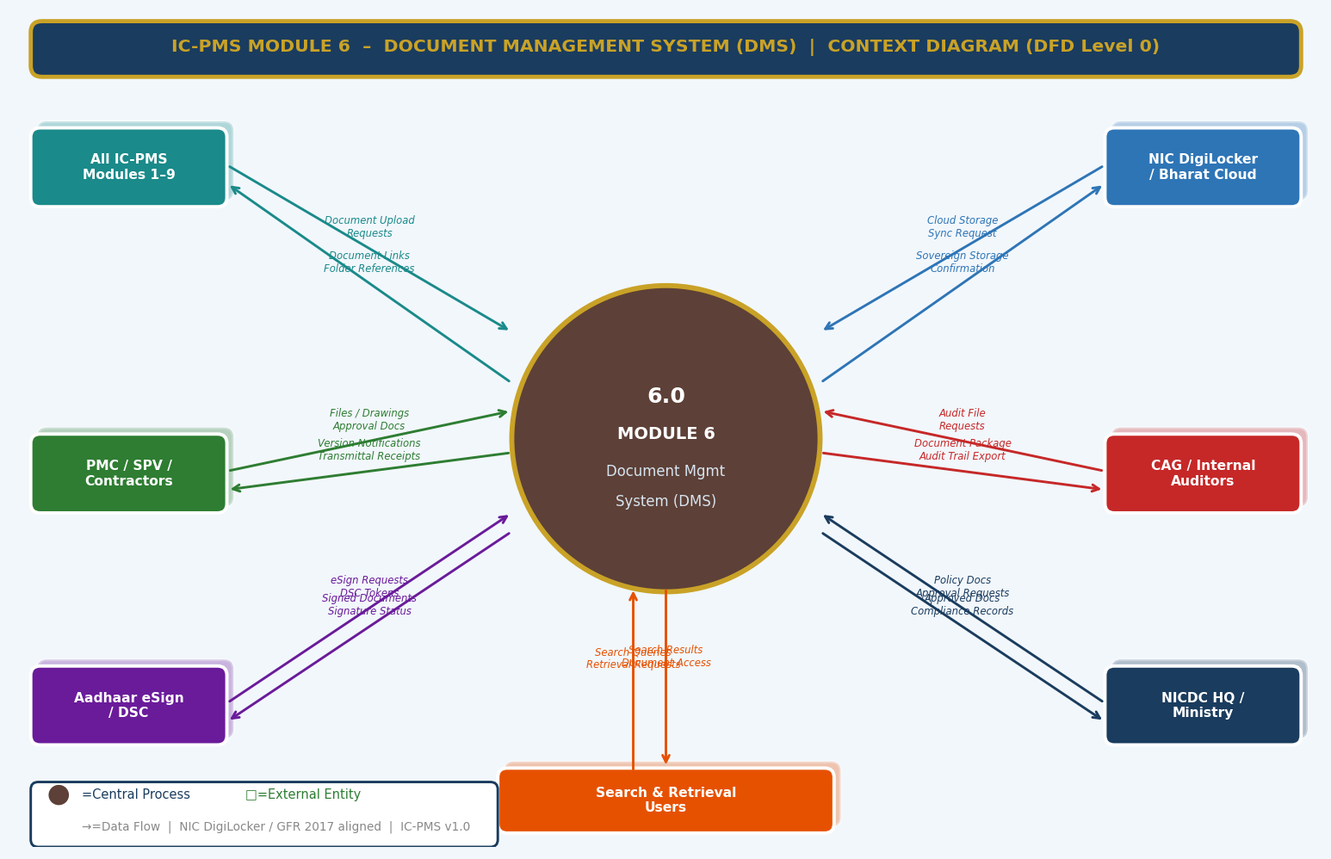
Figure 3.1 — DFD Level 0: Module 6 Context Diagram (All IC-PMS Modules, DigiLocker, eSign, CAG, Ministry)

External Entity Data Flow Summary
External Entity | Inputs to Module 6 | Outputs from Module 6
All IC-PMS Modules (1–9) | Document upload requests, file attachments from approval workflows, auto-generated reports | Document links (URLs), folder references, version confirmations, approval status callbacks
NIC DigiLocker / Bharat Cloud | Cloud storage confirmation, retrieval responses, sync status | Document files for sovereign cloud storage, checksum for integrity verification
PMC / SPV / Contractors | Engineering drawings, RA bills, method statements, RFI responses, quality records | Transmittal cover sheets, review comments, approval notifications, IFC drawings
CAG / Internal Auditors | Audit file requests, compliance queries, full document package requests | Complete document packages (ZIP), access audit trails, version history exports, approval records
Aadhaar eSign / DSC | OTP validation responses, signature tokens, signed PDF embeddings | eSign requests, document PDFs for signing, approval routing notifications
NICDC HQ / Ministry | Policy document submissions, approval decisions on major documents | Approved policy documents, compliance reports, project documentation summaries
Search & Retrieval Users | Search queries, filter parameters, document retrieval requests, bulk download requests | Search results with relevance scores, document previews, download packages

3.2 DFD Level 1 — Main Processes & Data Stores
The Level 1 DFD shows eight core DMS processes and eight data stores. The pipeline flows from folder structure management through document ingestion, version control, transmittal, drawing register, approval/eSign, search, and archival — with all processes sharing the central document store (D2).
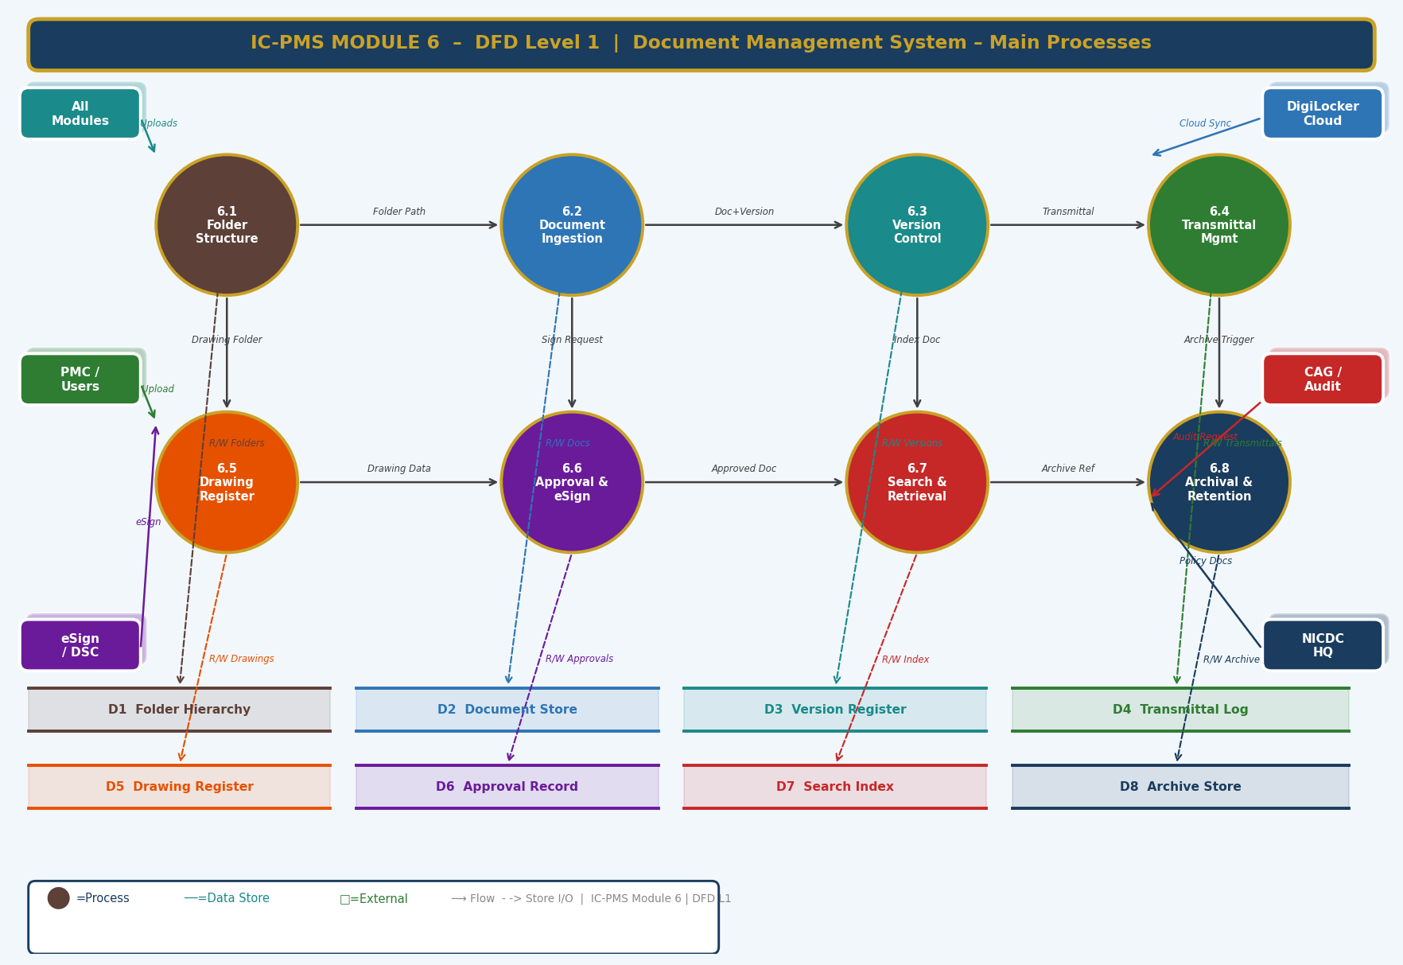
Figure 3.2 — DFD Level 1: Eight Core Processes and Eight Data Stores

Process and Data Store Descriptions
ID | Name | Function | Key Stores
6.1 | Folder Structure | Creates/manages WBS-mirrored folder hierarchy; sets access permissions; generates folder stubs on WBS publish | D1 Folder Hierarchy
6.2 | Document Ingestion | Validates, OCR-processes, virus-checks, version-assigns, cloud-syncs, and indexes all uploaded documents | D2 Document Store, D9 Metadata, D7 Search Index
6.3 | Version Control | Manages version numbering, locking, diff, rollback; maintains complete immutable version history | D3 Version Register
6.4 | Transmittal Management | Creates transmittal records, delivers to recipients, tracks acknowledgement and response, escalates overdue | D4 Transmittal Log
6.5 | Drawing Register | Manages discipline-wise drawing records, revision tracking, IFA/IFC workflow, CAD file management | D5 Drawing Register
6.6 | Approval & eSign | Routes documents for approval, manages eSign/DSC integration, locks approved versions, sends notifications | D6 Approval Record
6.7 | Search & Retrieval | Executes full-text and metadata search, provides document preview, manages bulk download | D7 Search Index
6.8 | Archival & Retention | Manages document lifecycle from Active to Cold Archive; triggers destruction approvals; enforces retention classes | D8 Archive Store

3.3 DFD Level 2 — Process 6.2: Document Ingestion Pipeline (Exploded)
The Level 2 DFD drills into the Document Ingestion Pipeline — the automated 8-step process that transforms an uploaded file into a fully indexed, versioned, cloud-synced, searchable document record. The virus/integrity check decision diamond is the critical quality gate that prevents malicious or corrupt files from entering the document store.
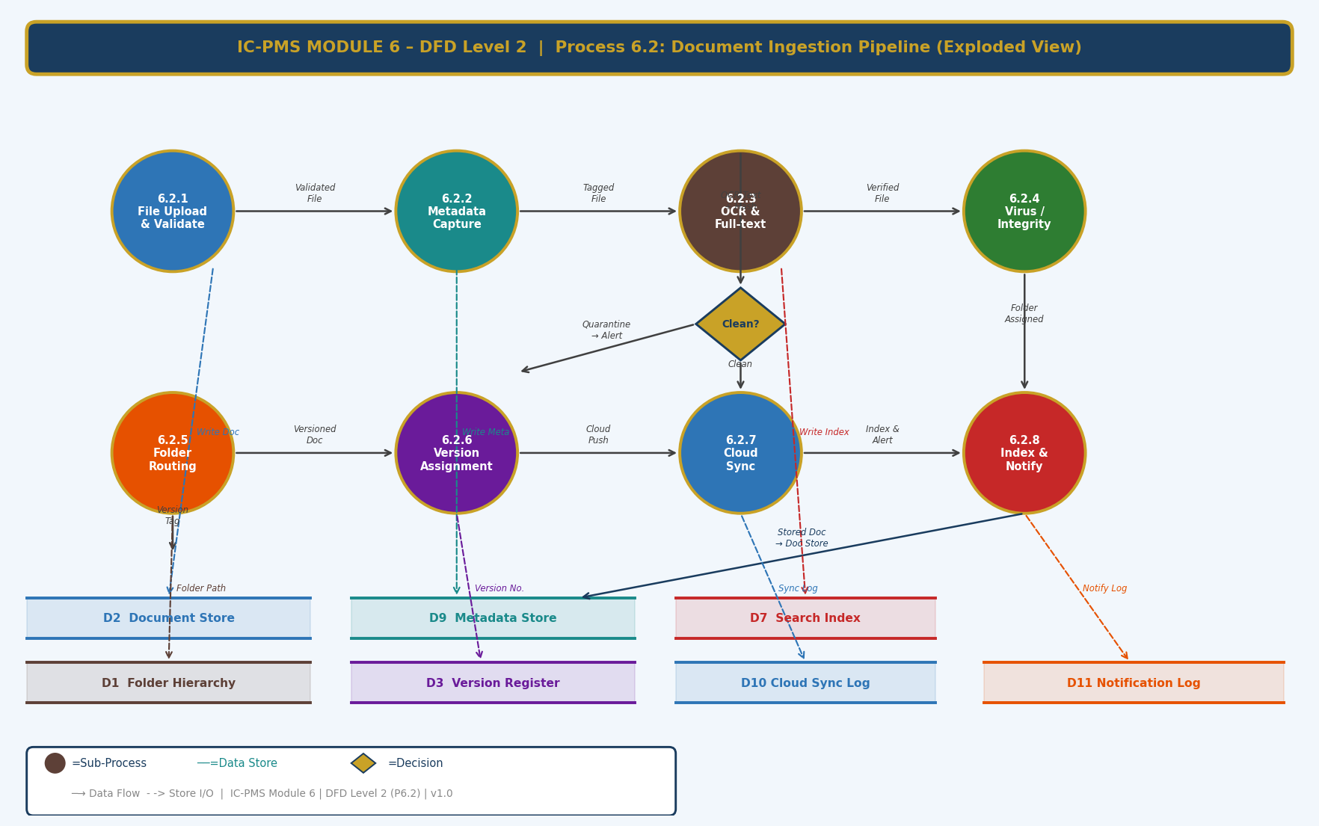
Figure 3.3 — DFD Level 2: Process 6.2 Document Ingestion Pipeline — 8 Sub-Processes with Clean/Quarantine Decision

Sub-Process Narrative
Sub-Process | Name | Description
6.2.1 | File Upload & Validate | User uploads file via drag-and-drop or API. System checks: format whitelist (PDF/DWG/DXF/DOCX/XLSX/PNG/JPG/MP4/ZIP), file size (< 100 MB individual; < 500 MB CAD package), filename convention warning. Rejected files returned to user with specific error. Accepted file staged in temporary quarantine storage.
6.2.2 | Metadata Capture | User completes metadata form: Document Code (auto-suggested from naming convention rules + WBS context), Title, Document Type (from controlled vocabulary), WBS Package (browse tree), Discipline (dropdown), Revision (letter + number), Status (IFA/IFC/For Comment/Approved). System auto-extracts file properties (author, creation date, page count from PDF/DOCX). All metadata written to D9 Metadata Store.
6.2.3 | OCR & Full-Text Extraction | Apache Tika processes DOCX/XLSX/PPT natively. Tesseract OCR processes PDFs and image files (multi-language: English + Hindi + regional scripts). DWG/DXF title blocks extracted by ezdxf Python library. Extracted text cleaned, normalised, and stored in Elasticsearch (D7 Search Index) alongside document metadata. OCR confidence score stored; low-confidence flagged for manual review.
6.2.4 | Virus & Integrity Check | ClamAV performs antivirus scan on staged file. SHA-256 hash computed. If virus detected: file quarantined, uploader notified, security alert to DMS admin, file never written to D2. If clean: SHA-256 hash written to version record for future integrity verification. Any future modification to the file will be detectable by hash mismatch.
6.2.5 | Folder Routing | System applies routing rules engine: matches {WBS_Package + Document_Type + Discipline} to target folder in D1. If exact match: auto-routes. If ambiguous: presents top 3 folder suggestions to user. If no match: user manually selects target folder. Routing decision logged. Document linked to confirmed folder path.
6.2.6 | Version Assignment | System queries D3 (Version Register) for existing documents with matching document code. If found: increments version (major/minor based on revision significance flag set by user); creates new version record linking to new file. If not found: creates v1.0 record as first version. Version status set to Draft. Previous version remains as Current until new version is approved.
6.2.7 | Cloud Sync | Document binary pushed to NIC DigiLocker via REST API (OAuth 2.0). Server-side SHA-256 checksum returned by DigiLocker compared against local hash. Match = sync confirmed; DigiLocker reference ID stored in D10 Cloud Sync Log. Mismatch = sync failed; retry scheduled. If DigiLocker unavailable for > 2 hours: document marked 'Sync Pending'; batch sync on API recovery.
6.2.8 | Index & Notify | Elasticsearch index updated with complete document record: metadata + OCR text + folder path + version + file hash + cloud reference. Watch subscriptions checked: users subscribed to this folder, document type, or WBS package receive email/in-app notification. Module callbacks fired: Module 4 notified for financial documents, Module 5 for contract documents, Module 2 for schedule reports.

4. Master Data Model

4.1 Entity Relationship Overview
The Module 6 master data model contains twelve entities. The Folder Hierarchy and Document Master are the root entities; the Version Register is the backbone of document integrity; Transmittal Log, Drawing Register, and Approval Record are operational entities; Archive Record, Access Log, and Cloud Sync Log provide the compliance and governance layer.
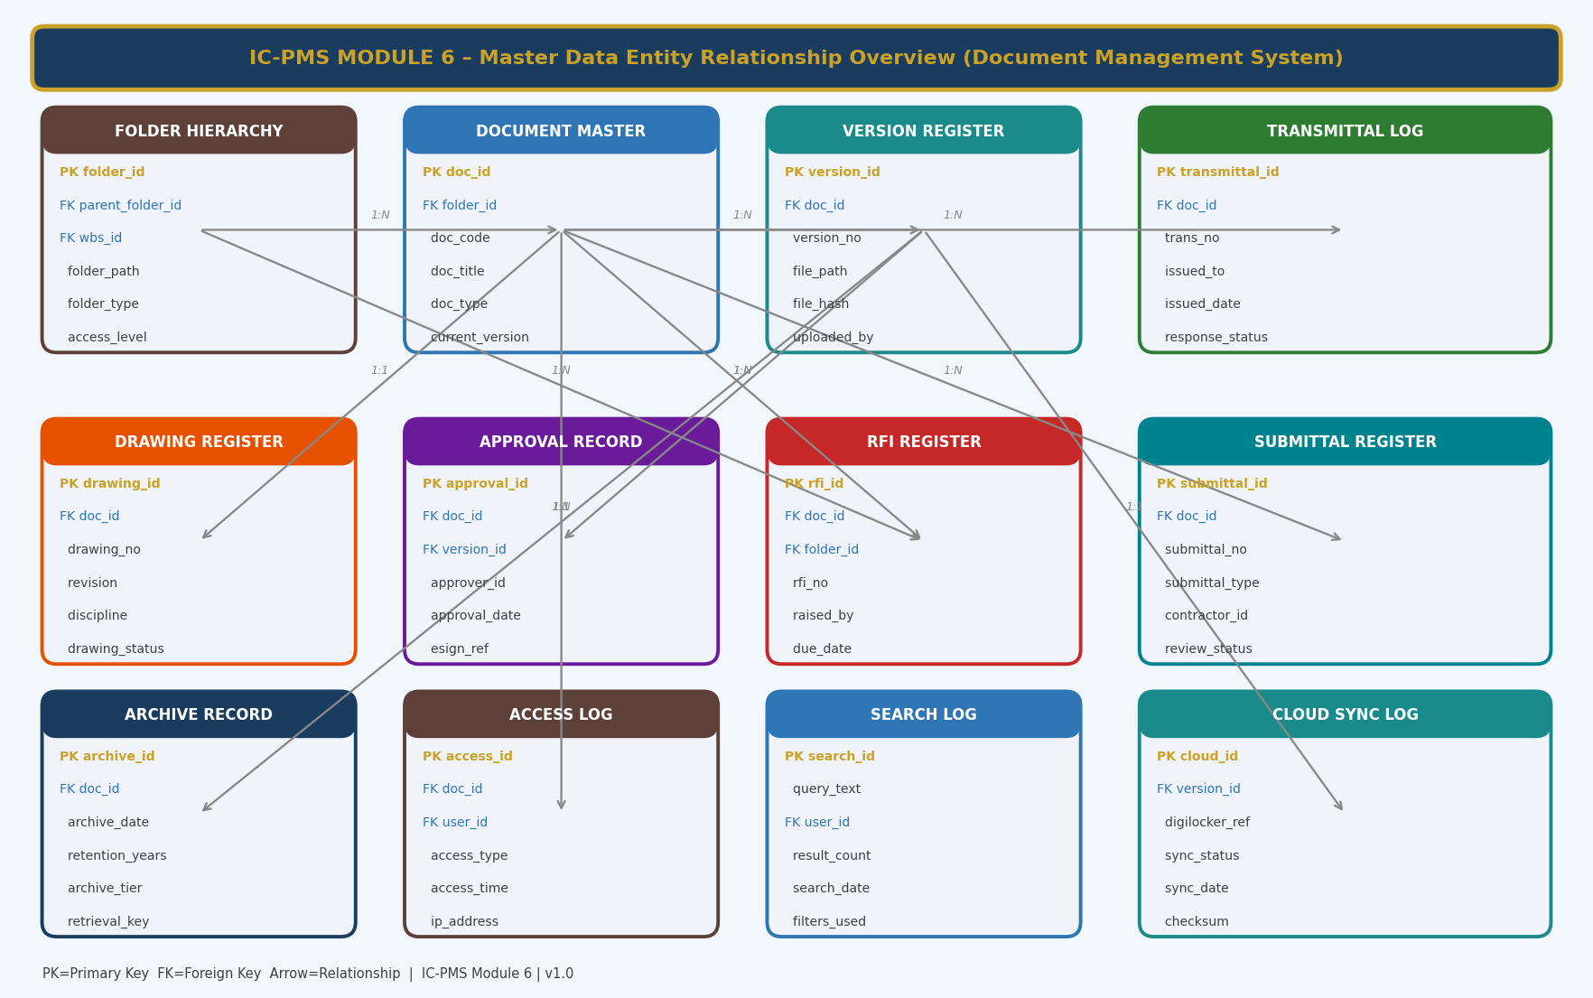
Figure 4.1 — Master Data Entity Relationship Overview (Module 6 — Document Management System)

4.2 Core Entity Field Definitions

4.2.1 Folder Hierarchy
folder_id | UUID — Primary Key
parent_folder_id | FK → Folder Hierarchy (self-referencing); NULL for root corridor folder
wbs_id | FK → Module 1 WBS Element — the project scope this folder belongs to
folder_name | VARCHAR — display name following NN_FolderName convention
folder_path | VARCHAR — full path (e.g. /DMIC/N03/03_Drawings/Civil_IFC); unique
folder_type | ENUM: Standard / Confidential / Legal / Archive / System
access_level | ENUM: Public_to_Project / Restricted / Confidential — inherited + override
allowed_roles_json | JSONB — list of OBS roles with access; inherits parent if NULL
document_count | INTEGER — computed: total documents in this folder and sub-folders
storage_size_mb | DECIMAL — computed: total size of all documents in this folder tree
auto_created | BOOLEAN — true if created by WBS publish automation; false if manual
created_date / last_activity | TIMESTAMP — creation and most recent document activity

4.2.2 Document Master
doc_id | UUID — Primary Key
folder_id | FK → Folder Hierarchy — primary folder this document belongs to
doc_code | VARCHAR — NIC-format document code (e.g. DMIC-P07-CIV-0142); globally unique
doc_title | VARCHAR — full descriptive title
doc_type | ENUM: Drawing / Contract / Report / RFI / Submittal / RA_Bill / Minutes / NCR / Safety / Environmental / Other
current_version | VARCHAR — current active version number (e.g. v3.0)
current_version_id | FK → Version Register — the current active version record
discipline | ENUM: Civil / Structural / Architectural / Electrical / Mechanical / Roads / ICT / None
wbs_id | FK → Module 1 WBS Element — the work scope this document pertains to
retention_class | ENUM: Permanent / Long_term / Standard / Short_term
is_locked | BOOLEAN — true if current version is locked (approved/signed); only new version can modify
doc_status | ENUM: Draft / Under_Review / Approved / Superseded / Voided / Archived
upload_date | TIMESTAMP — when the first version was uploaded
last_modified | TIMESTAMP — when the most recent version was uploaded

4.2.3 Version Register
version_id | UUID — Primary Key
doc_id | FK → Document Master
version_no | VARCHAR — e.g. v1.0, v1.1, v2.0, v3.0
version_type | ENUM: Major / Minor
revision_description | TEXT — mandatory description of changes in this version (min 20 chars)
file_path | VARCHAR — NIC MeghRaj storage path to the physical file
file_hash | VARCHAR(64) — SHA-256 hash of the file for integrity verification
file_size_mb | DECIMAL — file size in megabytes
file_format | ENUM: PDF / DWG / DXF / DOCX / XLSX / PNG / JPG / ZIP / MP4
ocr_text_index_id | VARCHAR — Elasticsearch document ID for OCR-extracted text
ocr_confidence | DECIMAL(5,2) — OCR accuracy score 0–100; NULL if non-OCR file type
uploaded_by | FK → User
upload_timestamp | TIMESTAMP WITH TIME ZONE
lock_date | TIMESTAMP — when this version was locked; NULL if still editable
locked_by | FK → User — person who locked this version
digilocker_ref | VARCHAR — NIC DigiLocker reference ID for this version's file

4.2.4 Transmittal Log
transmittal_id | UUID — Primary Key
trans_no | VARCHAR — sequential transmittal number (T-{WBS}-{Year}-{Seq})
doc_ids_json | JSONB — array of doc_ids transmitted in this transmittal
issued_by_org_id | FK → Organisation Master (Module 1 OBS)
issued_to_org_id | FK → Organisation Master
issued_date | TIMESTAMP
purpose_code | ENUM: For_Information / For_Review / For_Approval / For_Construction / As_Built
response_required | BOOLEAN
response_due_date | DATE — if response_required = true
receipt_confirmed_date | TIMESTAMP — when recipient acknowledged receipt; NULL if pending
response_status | ENUM: Pending / Approved / Approved_with_Comments / Rejected / Revise_Resubmit / Not_Required
response_date | TIMESTAMP — when response was provided
response_comments | TEXT — reviewer's comments
is_overdue | BOOLEAN — computed: response_required and response_due_date < today and response_status = Pending

4.2.5 Drawing Register
drawing_id | UUID — Primary Key
doc_id | FK → Document Master — the document record for this drawing
drawing_no | VARCHAR — discipline-specific drawing number
revision | VARCHAR — drawing revision letter (A, B, C...) and number
discipline | ENUM — drawing discipline (Civil, Structural, etc.)
drawing_title | VARCHAR — drawing title as shown on title block
scale | VARCHAR — drawing scale (e.g. 1:100, 1:500, NTS)
drawing_status | ENUM: IFA / IFC / For_Comment / Superseded / As_Built / Void
submitted_date | DATE — contractor submission date
review_due_date | DATE — PMC review SLA = submitted_date + 10 working days
review_date | DATE — actual PMC review completion date
ifc_date | DATE — date drawing was issued IFC; NULL if not yet IFC'd
reviewer_id | FK → User — PMC engineer who approved/IFC'd
cad_file_version_id | FK → Version Register — native DWG/DXF file version
wbs_id | FK → WBS Element — the physical scope this drawing covers

4.2.6 RFI Register
rfi_id | UUID — Primary Key
rfi_no | VARCHAR — sequential RFI number (RFI-{Package}-{Seq})
folder_id | FK → Folder Hierarchy — filed under relevant package folder
wbs_id | FK → WBS Element
drawing_id | FK → Drawing Register — the drawing the RFI relates to (if applicable)
rfi_title | VARCHAR — concise title of the query
rfi_description | TEXT — detailed description of the issue/query
raised_by_id | FK → User — engineer who raised the RFI
raised_date | DATE
assigned_to_id | FK → User — PMC/designer responsible for responding
due_date | DATE — response required by; typically 5–10 working days from raised_date
response_text | TEXT — PMC/designer response
response_date | DATE — actual response date
rfi_status | ENUM: Draft / Submitted / Under_Review / Answered / Closed / Overdue
is_overdue | BOOLEAN — computed: status != Answered/Closed and due_date < today

4.2.7 Submittal Register
submittal_id | UUID — Primary Key
submittal_no | VARCHAR — sequential (SUB-{Package}-{Seq})
doc_id | FK → Document Master — the submittal document
submittal_type | ENUM: Material_Approval / Shop_Drawing / Method_Statement / Quality_Plan / Safety_Plan / As_Built
contractor_id | FK → Organisation Master
submission_date | DATE
review_due_date | DATE — PMC review SLA = submission_date + 10 working days
review_status | ENUM: Pending / Under_Review / Approved / Approved_with_Comments / Returned / Rejected
review_comments | TEXT — PMC reviewer's comments
review_date | DATE — actual PMC review date
reviewer_id | FK → User — PMC engineer
resubmission_no | INTEGER — 0 for first submission; 1, 2... for each resubmission
linked_drawing_id | FK → Drawing Register — if submittal relates to a specific drawing
wbs_id | FK → WBS Element

5. UI/UX Screen Designs
Module 6 delivers five primary screens covering the main DMS workflows. The module uses warm brown (#5D4037) as its identity colour — evoking archival documents and records management. The design balances information density (needed for a document register with thousands of entries) with clarity — using clear status colour coding, compact list views with expandable detail, and a powerful search interface as the primary navigation mechanism for users who know what they need.

Screen 1 — DMS Dashboard
The DMS Dashboard is the document health overview — showing total document counts, pending approvals, open RFIs, storage utilisation, a live folder tree for quick navigation, the most recently uploaded documents, and an activity feed. It is designed for SPV DMS administrators and PMC document controllers who need an instant programme-wide document status.
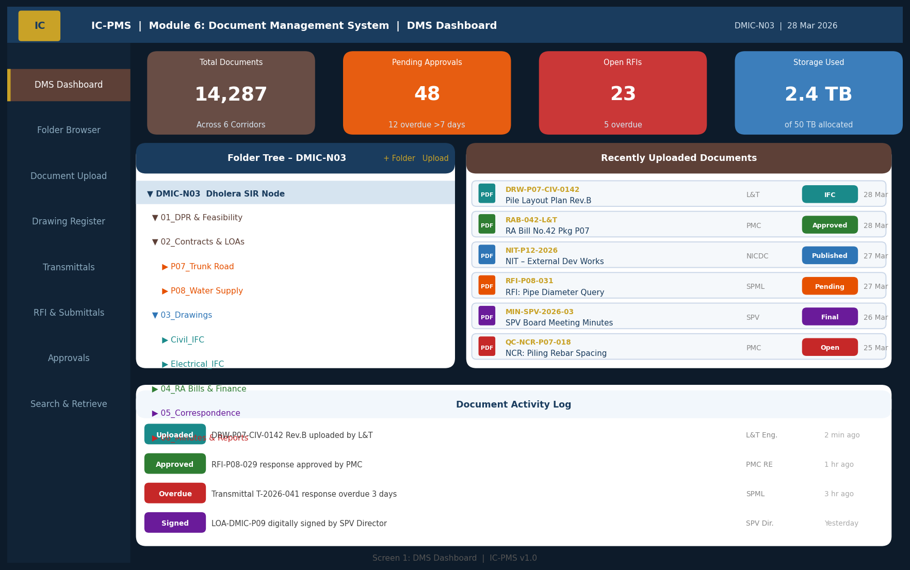
Figure 5.1 — DMS Dashboard (KPI Cards, Folder Tree, Recent Documents, Activity Log)

Dashboard UI Components
Component | Description | Interaction
KPI Cards (4 — top row) | Total Documents (with corridor total), Pending Approvals (with overdue count), Open RFIs, Storage Used (with quota). Colour-coded: orange if pending > 30, red if overdue > 5. | Click any card to navigate to filtered list view (e.g., 'Pending Approvals' card opens Approvals screen)
Folder Tree (left) | Collapsible 3-level tree showing Corridor → Node → Standard Sub-folders. Folder document count shown as a badge on each node. | Click folder to open Document Browser (Screen 2); right-click for folder options (Upload, New Sub-folder, Properties)
Recent Documents (right) | Last 6 uploaded documents with: file icon colour-coded by type, document code, title, author, status badge, date. Shows documents across all accessible corridors. | Click any document row to open document preview; click status badge to open approval/review screen
Activity Log (bottom) | Real-time feed of DMS events: uploads, approvals, overdue transmittals, eSign completions. Each event colour-coded by type. | Click any event to navigate to the relevant document

Screen 2 — Document Browser & Upload
The Document Browser is the primary file navigation and upload screen — a familiar file-explorer-style interface with a breadcrumb navigation bar, rich list view with sortable columns, and a drag-and-drop upload zone. It is designed to feel natural to engineers accustomed to Windows Explorer while adding the powerful metadata, version, and status information that a project DMS requires.
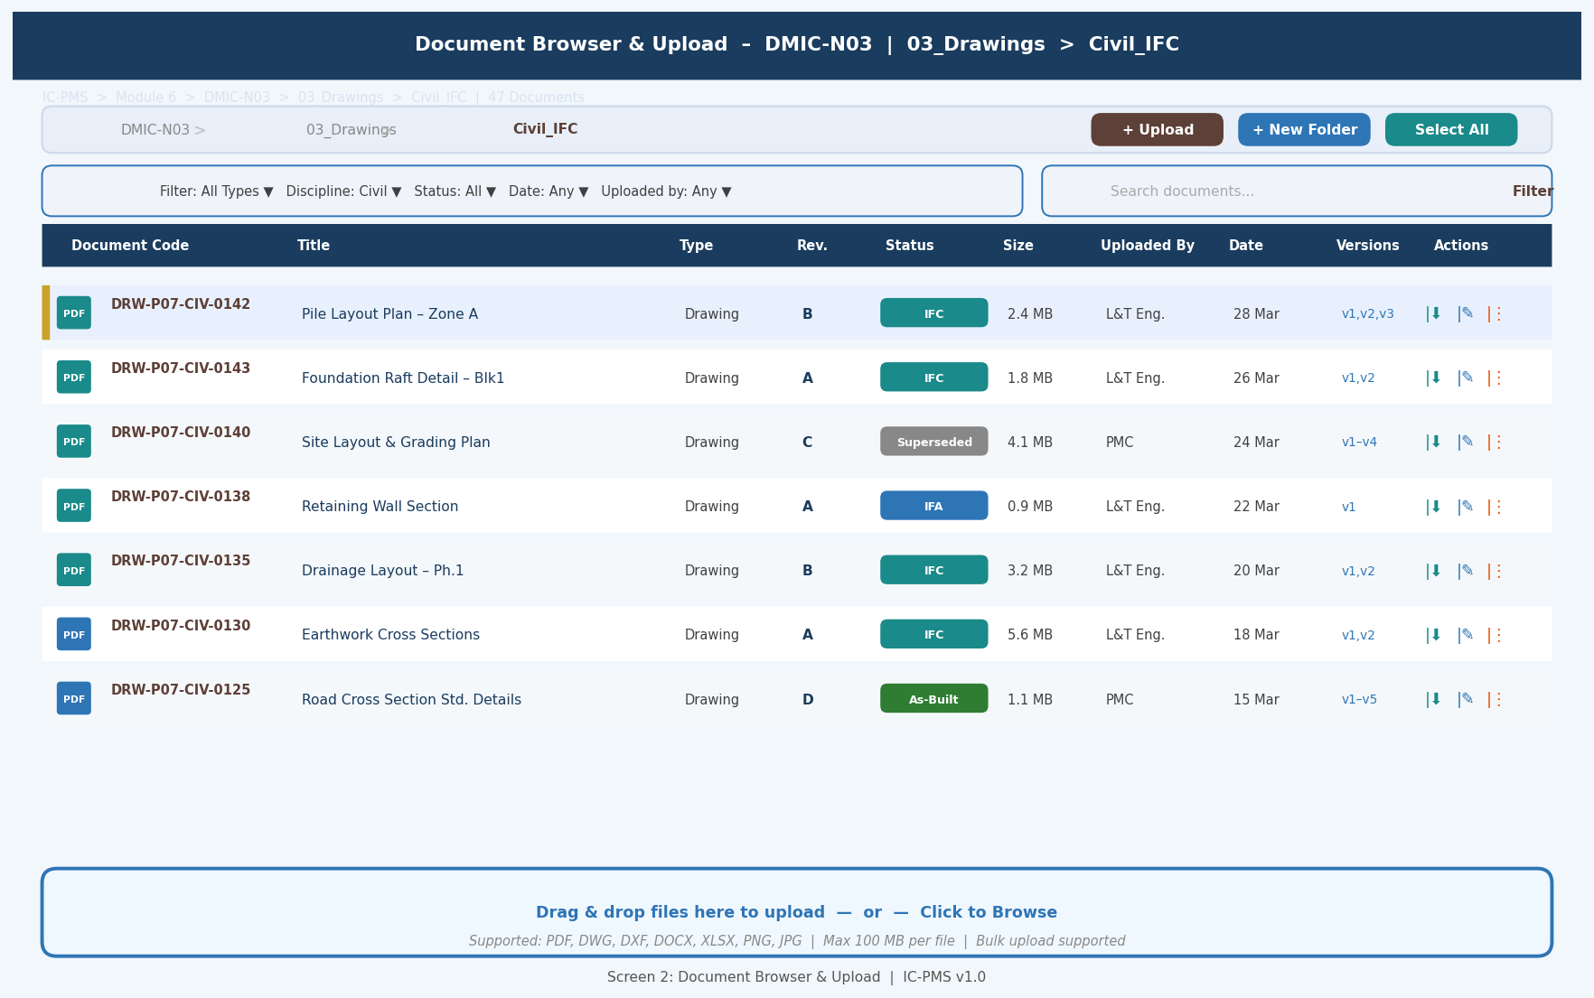
Figure 5.2 — Document Browser (Breadcrumb Navigation, Sortable List View, File Status Badges, Drag-and-Drop Upload Zone)

Browser Screen Design Decisions
- Breadcrumb navigation: Always shows the full folder path from corridor root; each segment is clickable to navigate up the tree — users always know where they are in the hierarchy
- Status badges: Every document row shows a colour-coded status badge (IFC = teal, IFA = blue, As-Built = green, Superseded = grey) — visible without opening the document
- Version indicator: 'Versions' column shows shorthand version history (e.g. 'v1,v2,v3') — clicking expands a full version timeline panel
- Action icons: Three per row — Download (arrow), Edit Metadata (pencil), More Options (three dots for Share, View History, Move, Delete) — keeps the list clean while providing full functionality on hover
- Upload zone: Fixed at the bottom of the browser panel — always visible; drag-and-drop or click to browse; shows upload progress bars for multiple simultaneous files; batch metadata form for bulk uploads
- Filter bar: Persistent above the list; supports compound filters (type + discipline + status + date) without page navigation — results update in real time

Screen 3 — Drawing Register
The Drawing Register is a specialised view for engineering drawings — showing discipline, revision, status, submission dates, PMC review status, and IFC date in a compact tabular format. It is the primary screen for PMC document controllers and site engineers tracking the drawing approval pipeline.
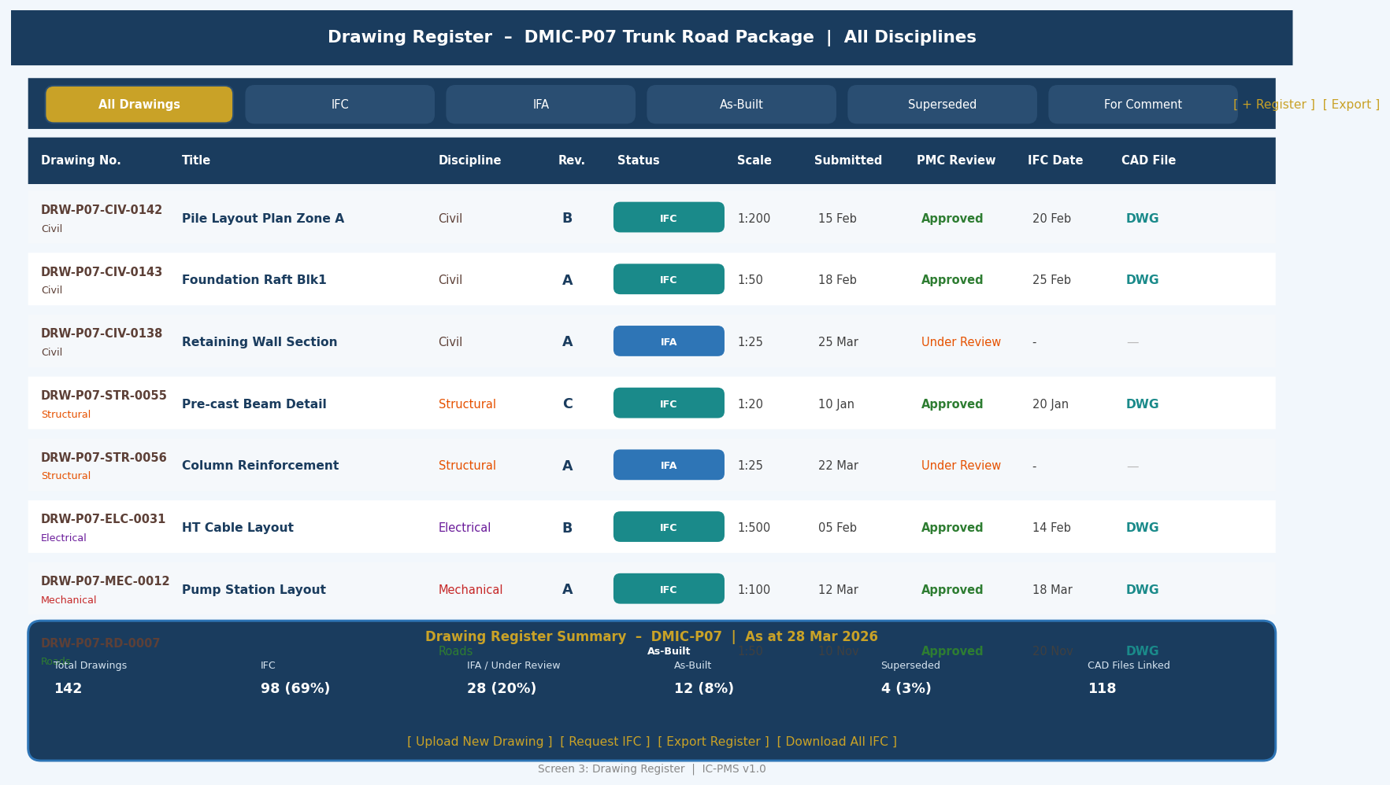
Figure 5.3 — Drawing Register (Status Filter Tabs, Discipline-coded Rows, IFC Pipeline, Summary Panel)

Drawing Register UX Design
Feature | Description
Status Filter Tabs | Six tabs (All, IFC, IFA, As-Built, Superseded, For Comment) with count badges; single click to filter list to that status. Prevents need for manual column filtering.
Discipline colour coding | Each row's drawing number has a coloured left dot matching the discipline (brown=Civil, orange=Structural, purple=Electrical, red=Mechanical, green=Roads). Allows instant discipline identification without reading the Discipline column.
Revision column | Revision letter shown bold; latest revision highlighted; clicking revision cell opens version comparison view showing what changed between this revision and previous.
PMC Review column | Shows 'Approved' (green), 'Under Review' (orange), '-' (not submitted). Overdue reviews (SLA breached) shown in red. PMC reviewer name shown on hover.
CAD File column | Shows 'DWG' link in teal if native CAD file available; '—' if PDF only. CAD download requires explicit permission; access request triggered if no permission.
IFC Date | Date the drawing was issued for construction. NULL shown as '—'. Clicking opens the IFC transmittal record for that drawing.
Summary panel (bottom) | Fixed summary showing total drawings, IFC%, IFA count, As-Built count, Superseded count, CAD files linked. Refreshes with filter changes.

Screen 4 — RFI & Submittal Tracker
The RFI and Submittal Tracker presents both registers side-by-side — the two document workflows that most directly affect construction progress. Overdue items are visually prominent. The screen is the daily working tool for PMC Resident Engineers managing the document review pipeline.
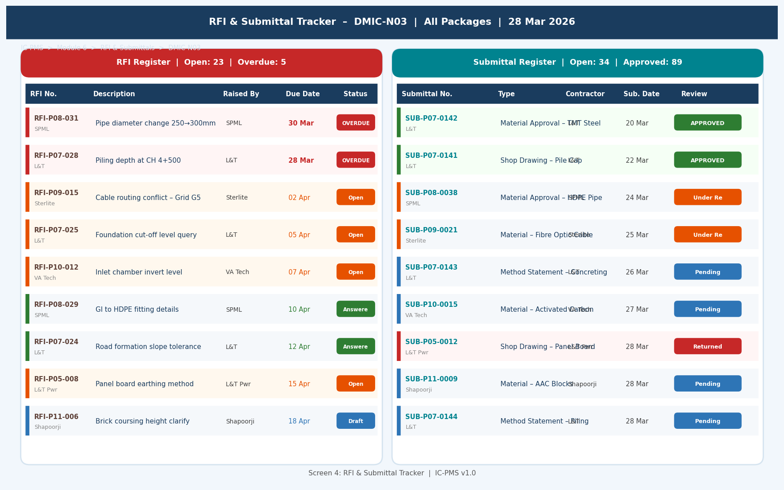
Figure 5.4 — RFI & Submittal Tracker (Side-by-Side RFI and Submittal Panels, Overdue Highlighting, Status Badges)

RFI & Submittal Screen Design
- Side-by-side panels: RFI register on the left, Submittal register on the right — PMC engineer can manage both workflows from a single screen without tab switching
- Overdue highlighting: Overdue items (past due date with no response) shown with red left stripe and red due date — immediately visible even when the list is long
- Colour-coded left stripe: Each row has a coloured stripe on the left edge matching the status (red=overdue, orange=open, green=answered/approved, blue=pending)
- Compact rows with two-line layout: Line 1 = RFI/Submittal number + status badge; Line 2 = description + raised by. Two lines of information without vertical space waste
- Due date countdown: For open items, due date shown; for overdue items, days overdue shown in red (e.g., 'OVERDUE: 3 days')
- Quick response: Clicking a row opens a slide-in panel on the right for entering a response without navigating away from the tracker list

Screen 5 — Full-Text Search & Retrieval
The Search screen is the most powerful navigation tool in Module 6 — enabling users to find any document in the tens-of-thousands-strong repository by searching the full text of all documents, not just titles and metadata. The search experience is designed to feel as fast and intuitive as a web search engine, with contextual filters and relevance ranking.
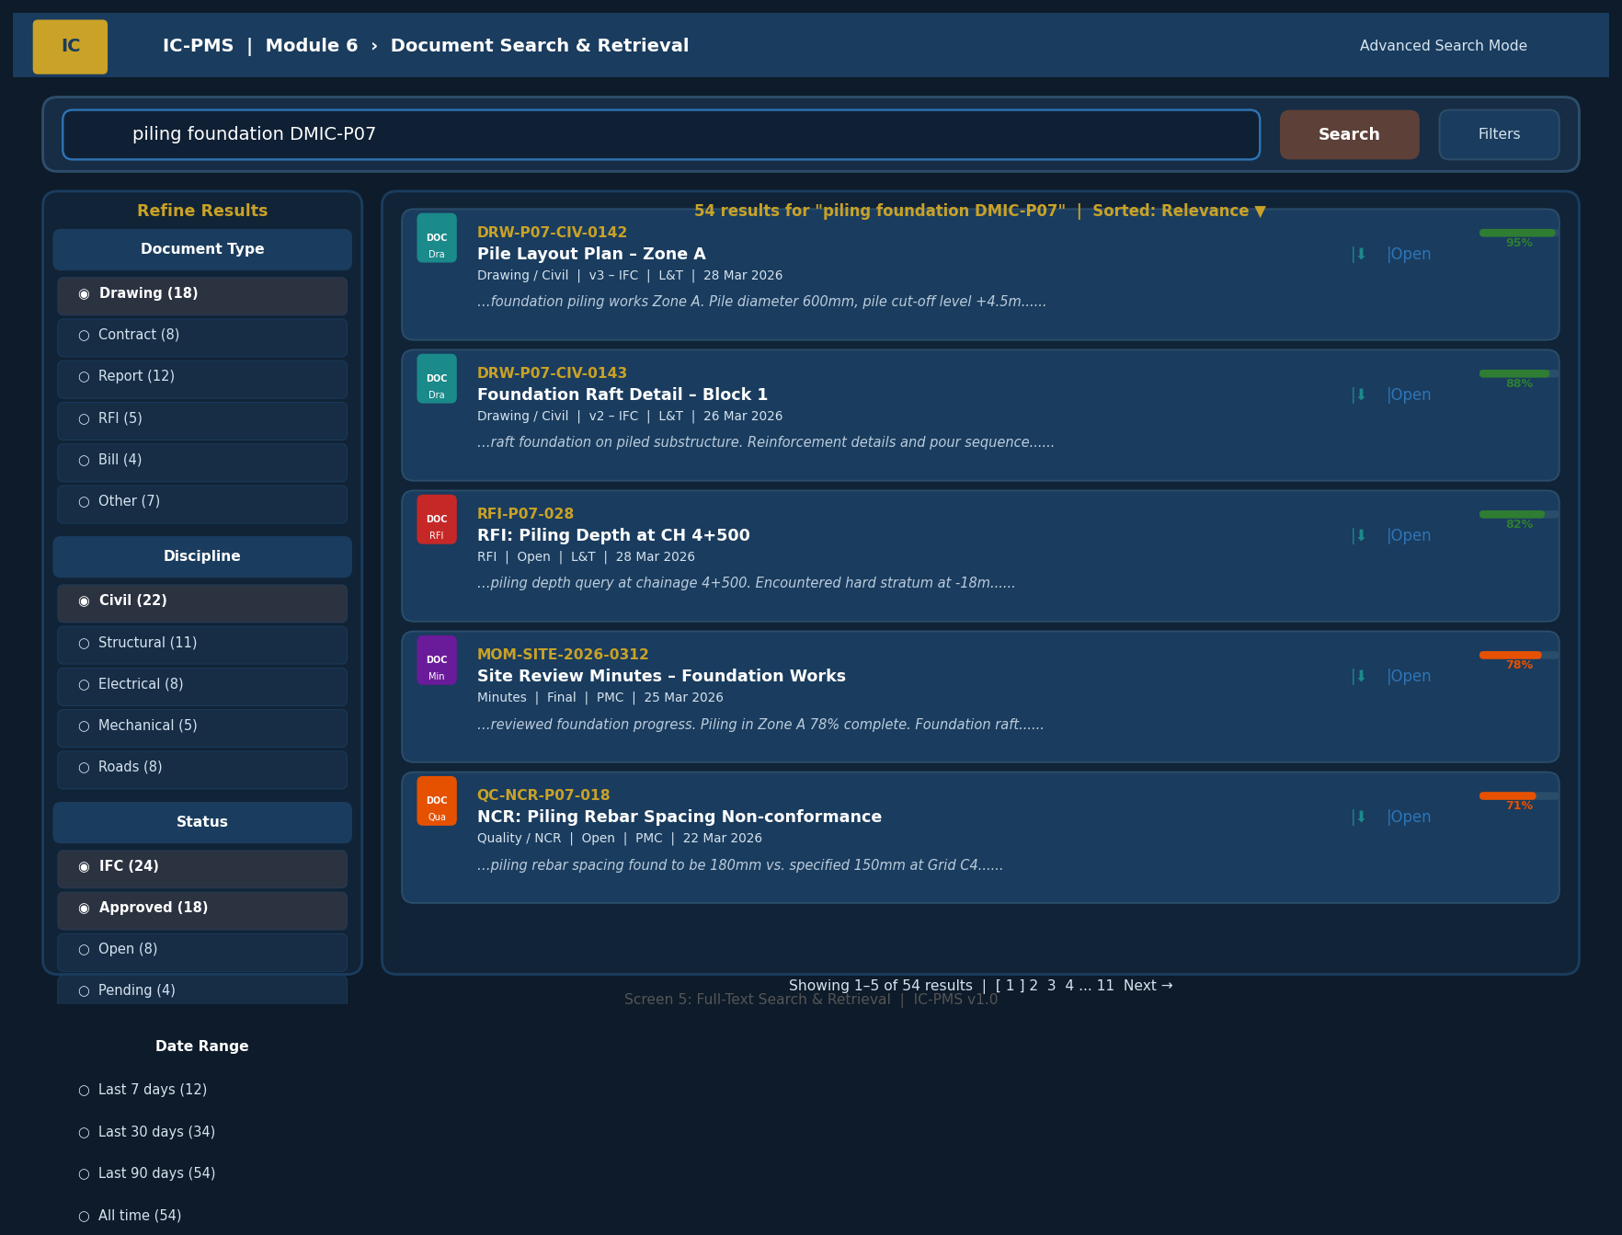
Figure 5.5 — Full-Text Search (Search Bar, Faceted Filters, Relevance-Ranked Results with Snippets and Highlighting)

Search Screen Design Principles
- Prominent search bar: Full-width search bar is the hero element of the screen — visually prominent, always in focus when screen loads, with instant search-as-you-type suggestions
- Faceted filters (left panel): Four filter groups (Document Type, Discipline, Status, Date Range) with document counts shown in parentheses for each value — users can see how many results each filter will produce before applying it
- Result cards with snippets: Each result shown as a rich card — file icon (colour = document type), document code, title, document type, status, author, date, and a text snippet showing the matching search terms in context
- Relevance percentage bar: A small green/amber bar and percentage score (e.g. '95%') on the right of each result card shows search relevance — helps users quickly identify the most relevant result
- Term highlighting: Matched search terms highlighted in yellow within the snippet text — users can immediately see why a document was returned
- One-click actions per result: Each result card has Download and Open icons — users can download without navigating away from search results

6. Business Rules & Validation Logic

6.1 Document Upload Rules
Rule ID | Description | Outcome
DMS-001 | Document code must follow the NIC naming convention: {WBS_Code}-{Discipline}-{Sequential_4digits} | Warning shown on upload; user can override with justification; non-compliant codes flagged in DMS admin report
DMS-002 | No document can be uploaded to a folder outside the user's OBS-WBS access permissions | Error: 'You do not have upload permission for this folder. Contact your DMS Administrator.'
DMS-003 | Files that fail virus scan (ClamAV) are quarantined and never committed to the document store | Alert to DMS admin and uploader; quarantine log entry; file purged after 7 days if not reviewed
DMS-004 | Duplicate document code detection: if a document with the same code exists, upload is treated as a new version — user must confirm version type (Major/Minor) before proceeding | Blocking: 'Document code DRW-P07-CIV-0142 already exists (current: v2.0). Uploading as v2.1 (Minor) or v3.0 (Major)?'
DMS-005 | PDF files > 10 pages with no extractable text layer are automatically sent for OCR; processing may take up to 5 minutes | Notification to uploader: 'Your document is being OCR-processed. It will be searchable within 5 minutes.'

6.2 Version Control & Approval Rules
Rule ID | Description | Outcome
DMS-006 | A locked (approved/signed) version cannot be edited or deleted; only a new version can supersede it | Edit attempt on locked version: 'This version is locked. Create a new version to make changes.'
DMS-007 | Drawing status can only follow the valid progression: IFA → IFC → As-Built / Superseded / Void. A drawing cannot go from IFC back to IFA without PMC Director approval | Workflow block; 'Regression of drawing status from IFC to IFA requires PMC Director approval. Initiate approval workflow?'
DMS-008 | An IFC drawing supersedes all previous revisions of the same drawing number. System auto-updates previous revisions to 'Superseded' status | Automatic status update to all previous revisions; notification sent to all users who have downloaded previous versions
DMS-009 | PMC approval SLA for drawing review is 10 working days. Overdue reviews are escalated to PMC Team Leader at day 12 and PMC Project Manager at day 15 | Automated escalation emails; escalation logged in audit trail; overdue count shown in Dashboard KPI
DMS-010 | Aadhaar eSign requires successful OTP verification; DSC sign requires valid non-expired Class 3 certificate. Expired certificates block signing with error | eSign error: 'Your DSC certificate has expired on [date]. Please renew your DSC to proceed.'

6.3 Retention & Archive Rules
Rule ID | Description | Outcome
DMS-011 | No document can be permanently deleted without dual approval from NICDC Records Officer and NICDC Legal; destruction must be logged in permanent audit trail | Blocking: deletion requires two-approver workflow; auto-rejection if Legal Hold is active on any document in the batch
DMS-012 | Documents under Legal Hold (litigation, audit, or arbitration) cannot transition to Cold Archive or be scheduled for destruction until hold is lifted | Archival transition blocked; Legal Hold status shown prominently on document record; notification to Records Officer
DMS-013 | Cold-archived documents must be retrievable within 24 hours of request; failure to retrieve triggers immediate escalation to NIC and NICDC IT Director | SLA monitoring on retrieval requests; NIC MeghRaj availability SLA in contract

7. Integration Touchpoints

7.1 Internal Module Integrations
Module | Data Exchanged | Trigger / Frequency
Module 1 — WBS | Inbound: WBS publish event triggers auto-creation of folder hierarchy; WBS element metadata for folder naming; OBS-WBS access matrix for folder permissions | On WBS Publish; on OBS-WBS mapping change
Module 2 — Scheduling | Inbound: Schedule baselines, look-ahead PDFs, MPR reports auto-filed in DMS; Outbound: Document status (e.g., drawing IFC date) as schedule milestone evidence | On report generation in Module 2; on schedule baseline approval
Module 3 — Satellite | Inbound: Satellite evidence packages (AI classification images, encroachment evidence PDFs) auto-filed under relevant WBS package folder | On alert generation; on monthly MPR generation
Module 4 — Cost Management | Inbound: RA Bills, payment advice, audit reports auto-filed; RCE documents stored; Outbound: Document existence check for invoice approval gating | On RA Bill upload; on PFMS payment; on RCE approval
Module 5 — Contract Management | Inbound: Tender documents, LOAs, VOs, correspondence auto-filed; Outbound: Document URLs for transmittal; contract document status for approval workflows | On all contract lifecycle events (NIT publish, LOA issue, VO approval, notice issuance)
Module 9 — Reporting | Inbound: Monthly Progress Reports, Executive Dashboards auto-filed; Outbound: Document count and status data for programme-level DMS health KPIs | On each report generation cycle

7.2 External System Integrations
System | Integration | Data Flow | Protocol
NIC DigiLocker | REST API — bidirectional | Primary sovereign cloud storage for all document files; SHA-256 checksum validation; DigiLocker reference ID stored per version | DigiLocker API v3; OAuth 2.0; AES-256 encryption in transit and at rest
Bharat Cloud (NIC) | REST API — write | Secondary/backup storage tier for documents above 7 years; cold archive tier | Bharat Cloud S3-compatible object storage API
Aadhaar eSign (CDAC / eMudhra) | REST API — eSign | OTP-based Aadhaar authentication for eSign; PDF/A-3 signed document generation and return | CDAC eSign API v2; Aadhaar OTP; legally valid under IT Act 2000
DSC / Class 3 Certificate Authority | Browser plugin + REST | USB DSC token for senior officer digital signatures; certificate validation against CCA/NIC CA | NIC CA / e-Mudhra CA API; PKCS#7 signature format; PDF/A-3
Elasticsearch (internal) | REST API — bidirectional | Full-text indexing of all document content + metadata; search query execution | Self-hosted Elasticsearch 8.x on NIC MeghRaj; vector search for semantic similarity
Tesseract / Apache Tika (internal) | Library calls | OCR processing of uploaded PDF/image files; text extraction from DOCX/XLSX/PPT | Tesseract 5.x; Apache Tika 2.x; called within document ingestion pipeline
National Archives of India (NAI) | REST API — write (future) | Transfer of Permanent class documents to NAI digital repository at 30-year mark | NAI Digital Repository API (under development); XML metadata transfer

8. Workflow & Approval Chains

8.1 Drawing Approval (IFA to IFC) Workflow
Step | Actor | Action | SLA
1 | Contractor | Upload drawing as IFA with transmittal to PMC | Day 0
2 | System | Auto-routes to Drawing Register; creates transmittal record; sends PMC notification | Immediate
3 | PMC Draftsman | Technical check — title block, scale, drawing number, discipline | Day 1–2
4 | PMC Resident Engineer | Technical review — compliance with specifications, codes, and site conditions; markups on PDF | Day 3–8
5a (Approved) | PMC RE | Marks drawing IFC; applies DSC/eSign to approval certificate; drawing status updated | Day 8–10
5b (Revise) | PMC RE | Issues review comments via transmittal (Revise & Resubmit); contractor resubmits | Restart from Step 1 for new revision
6 | System | IFC drawing published to all users; previous revision auto-superseded; notification to site teams | Immediate on Step 5a

8.2 RFI Response Workflow
Step | Actor | Action | SLA
1 | Contractor / Site Engineer | Raise RFI in system with description, relevant drawing reference, query, urgency flag | Day 0
2 | System | RFI logged and numbered; auto-assigned to PMC RE based on discipline; notification sent | Immediate
3 | PMC Resident Engineer | Reviews query; consults designer if required; prepares response | Day 1–5
4a (Answered) | PMC RE | Submits response in system; RFI status = Answered; contractor notified | Day 5 standard; Day 2 for urgent
4b (Escalate) | PMC RE | If response requires designer/NICDC decision, escalates with recommendation | PMC + Designer to respond within 7 days
5 | Contractor | Acknowledges RFI response; confirms understanding; RFI closed | Within 2 days of receiving response

9. Performance & Non-Functional Requirements
Requirement | Specification | Measurement
Document upload response | File upload and metadata save < 5 seconds for files up to 10 MB; progress bar for larger files | Upload completion time; P95 under load
OCR processing time | < 5 minutes for a 50-page A4 PDF document | OCR pipeline job completion log
Full-text search response | < 2 seconds for any query returning up to 1,000 results | Elasticsearch query time; P95 under 100 concurrent searches
DigiLocker sync latency | < 60 seconds from upload to DigiLocker confirmation | API call timing; alert if > 5 minutes
Drawing register load | < 3 seconds to load 500-drawing register with all metadata | Page load time; Lighthouse audit
Concurrent users | 300 simultaneous DMS users (upload, search, browse) without degradation | k6 load test at 300 VUs for 30 minutes
Cold archive retrieval | < 24 hours from retrieval request to document online | Retrieval request SLA monitoring
Storage scalability | System must support up to 100 TB total document storage across all corridors | NIC MeghRaj storage scaling policy
eSign processing | < 30 seconds for Aadhaar eSign OTP flow; < 5 seconds for DSC token signing | eSign API response time
Data retention | 30 years with documented retrieval test annually; 100% of Permanent class documents preserved | Annual DR drill; retention policy compliance audit

10. Glossary — Module 6 Terms
Term | Definition
DMS | Document Management System — centralised repository for creating, storing, retrieving, and managing project documents
OCR | Optical Character Recognition — technology that converts scanned images of text into machine-readable text for search indexing
eSign | Electronic Signature — Aadhaar OTP-based digital signature legally valid under IT Act 2000 and the Aadhaar (Targeted Delivery) Act
DSC | Digital Signature Certificate — USB hardware token containing a PKI certificate (Class 3) for generating legally binding digital signatures
IFA | Issued for Approval — drawing status indicating the drawing has been submitted for PMC technical review
IFC | Issued for Construction — drawing status indicating PMC approval; drawing may be used on site for construction
As-Built | As-Built Drawing — final drawing showing the actual constructed state; issued after work completion and PMC certification
Transmittal | A formal document issue record that tracks what was issued, to whom, when, and whether a response was received
RFI | Request for Information — formal query raised by a contractor to the PMC/designer seeking clarification on drawings, specifications, or site conditions
Submittal | A formal submission by the contractor for PMC approval — includes material approval requests, shop drawings, method statements, quality plans
NCR | Non-Conformance Report — PMC's formal record of work that does not conform to specifications or drawing requirements
Retention Class | Category assigned to each document determining its minimum storage period (Permanent / Long-term 30yr / Standard 10yr / Short-term 3yr)
Legal Hold | Status placed on documents that are subject to ongoing litigation, audit, or arbitration — prevents archival or deletion
Cold Archive | Low-cost storage tier for documents older than 7 years post project completion; 24-hour retrieval time
DigiLocker | NIC-operated sovereign cloud storage platform for government documents; used as primary storage for IC-PMS DMS
Bharat Cloud | NIC's commercial cloud infrastructure; used as secondary and archival storage tier for IC-PMS
SHA-256 | Secure Hash Algorithm 256-bit — cryptographic hash function used to generate a unique fingerprint of each document file for integrity verification
Elasticsearch | Open-source distributed search and analytics engine; used by IC-PMS DMS for full-text document search indexing
Tesseract | Open-source OCR engine developed by Google; used to extract text from scanned PDF and image documents
PDF/A-3 | ISO-standardised PDF format for long-term archival; supports embedded digital signatures; required for GFR-compliant electronic records

